A Detailed Game Specification:
Tetris
Course: COMP 2659, Winter 2026
Instructor: Nolan Shaw
Author(s): Takhdeer Grewal, Henry Mejia, Aaron Arrieta
Last Modified: January 23, 2026

1. General Game Overview
Tetris is a challenging one or two-player game that involves stacking blocks (called Tetriminos) on a gridded matrix. Players must move, rotate, and place falling blocks calculatingly to avoid exceeding the max height of the matrix. For the one-player version, the game starts off with an empty matrix and prompts the player with one tetrimino at a time. Players will not be able to place blocks outside of the matrix. Tetriminos may be cleared horizontally if and only if lines are filled with blocks with no empty spaces. Multiple lines can be cleared if they are all filled in (called a “Tetris” when 4 lines are cleared after placing one block); this is also how players can earn points to add to their score. As lines are cleared, the blocks progressively fall faster (changes levels), making it more challenging for players to continue stacking and clearing lines. Throughout the gameplay, the number of cleared lines and score is displayed to the side of the screen. If the blocks exceed the matrix, the game is over. The overall objective of Tetris is to score as many points as possible (by clearing lines), until the player’s stack has exceeded the matrix.
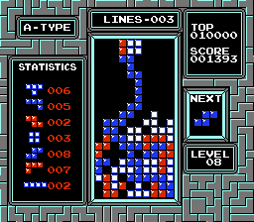
(from https://www.retrogames.cz/play_1030-NES.php)

2. Game Play Details for Core 1-Player Version

Objectives and Rules
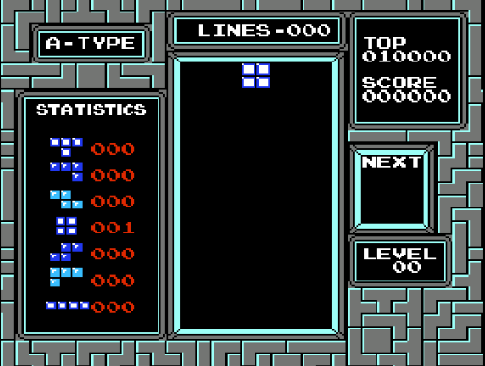
(from https://www.retrogames.cz/play_1030-NES.php)
A game of Tetris starts off with an empty matrix with the level and score displays set to 0. All falling physics and multipliers to the score are set to the base settings for level 0 (gravity tick is 1 row / second and x1 score multiplier). The player is immediately prompted with a randomized tetrimino at the top middle of the matrix and begins falling down the grid.
The main objective of Tetris is to clear as many lines while levels progressively become more challenging, and obtain as many points until the player’s stack has exceeded the matrix.
Players are able to move the tetrimino left and right within the matrix, as well as “soft dropping” the block which speeds up the falling physics for the block. If a player attempts to exceed the matrix horizontally, the tetriminos simply will not be able to move further than the matrix. There is also an option to “hard drop” the tetrimino which immediately drops directly below the area they hover over. Players are able to rotate the tetrimino clockwise to help fit the blocks more effectively.
To gain points for the player’s score, the player must “clear” multiple lines. In order to clear a line, the row of a line must be filled up with the tetriminos with no empty gaps. It is possible to clear multiple lines after one drop (it is called a “tetris” when four lines are cleared in one drop). The point scoring also varies depending on how many lines are cleared and how the tetrimino is dropped. For the drops, players gain 1 x Distance for a soft drop, and 2 x Distance for a hard drop. For line clears, players are rewarded 100 points for a single line clear, 300 points for a double line clear, 500 for a triple line clear, and 800 points for a tetris (four line clear). After a certain amount of lines are cleared, the level increases. Each level increases the gravity speed of the tetrimino and adds a multiplier to the score, increasing the points rewarded after clears.
In Tetris, there is no true win condition to win. The player’s objective is to see how long they can last and how many points they can score in doing so. The game is over when the tetriminos stacked by the player vertically exceed the matrix. When the game ends, it ends with a message indicating that the round is game over and displays their score for that run.
[Description of game rules goes here. Include scoring/winning/losing conditions as applicable.]

Objects
Object or Object Type Name | Properties | Behaviours | Graphical Image
Tetromino | - 7 distinct pieces with different shapes  - Has falling physics (affected by game settings)  - Has collision physics with matrix perimeter and other tetrominoes | - Can be moved in directions: up, down, left, right  - Can be soft dropped (neutral, partial placement)  - Can be hard dropped (fast, absolute placement)  - Can be rotated 90 degrees (TBD to be CW or CCW rotation)  - Can be held/stored | 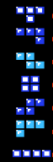  Figure 1
Matrix Grid | - Defined playable area  - Available space where tetrominoes can be placed | - N/A (matrix grid is fixed and defined during gameplay) | 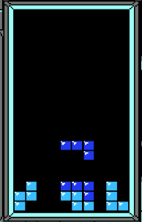  Figure 2
Store/Hold Box | - Separate area containing user’s desired tetromino to be “held” or “stored”  - Holds 1 tetromino piece  - Located on the left of the game screen | - Is updated when player decides to hold only 1 specific tetromino  - If held tetromino is used, held box is empty until the next held tetromino is chosen | 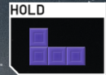  Figure 3
Next Box | - Separate area displaying the next tetromino(es) to be placed  - Displays 1 tetromino (arbitrarily chosen)  - Located on the right side of the game screen | - Continuously updates until game is finished  - Displays succeeding tetromino to be placed | 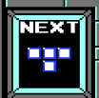  Figure 4
? Ghost Piece | - Mimics the shape of current Tetromino to be placed, its outline will be faintly highlighted at its placement spot | - Tracks movement of tetromino, display its respective shape at its current placement position | 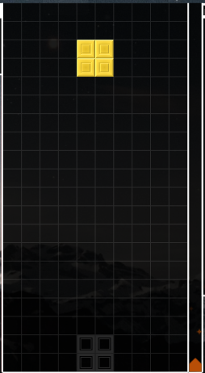  Figure 5

Images found in Figure 1, 2, 4 located in “Graphical Images” Column (from https://www.retrogames.cz/play_1030-NES.php)
Images found in Figure 3, 5 located in “Graphical Images” Column (from https://tetr.io/)
[Note: for some games, it may not be appropriate or realistic to include images for all object types. However, this is recommended if possible. Simple bitmap-style images (e.g. 8×8, 4×4, 16×16, etc.) are best for many game types. There are free tools to help you construct such images.]
[Note: for some games a particular object may have >1 associated image, depending on its current state (e.g. Mario walking left vs. Mario walking right).]

Physics
Objectives and rules:
Tetris is played in a 10 columns wide x 20 rows tall playfield, Pieces can not move outside the grid matrix. The game ends if the tetriminos stack exceeds the top. On the contrary, when a tetrimino reaches the bottom (for ex. row 20 for the first piece) it will stop falling and lock in place; it can no longer move, be rotated or moved once locked. Afterwards a new piece is generated (via a RNG) at the top.

Gravity:
The gravity of the game is simulated so that every piece moves down 1 cell in the matrix at a regular time interval. This interval is called the “gravity tick” or “drop speed”, this changes with respect to the current level. At level 0 the gravity tick is set to 1 row / second. There is no acceleration of the pieces as they fall. As the speed increases there is shorter time between gravity ticks as the overall velocity within each tick does not change. No matter the level, gravity moves pieces exactly 1 cell per tick.

Player Controls:
Soft drop:
Holding the down arrow key, increases the gravity tick temporarily, to between 10-20x faster than the current gravity tick. While still maintaining the fall at 1 cell / tick. This awards the player a bonus at (1 x distance dropped) in addition to an incremental increase per level.
Hard drop:
Pressing the space bar, instantly moves the piece to the lowest possible position and locks the piece into place instantly afterwards. There is no gradual falling animation unlike soft drop.

Lock Control:
When a piece touches the bottom or another piece, the gravity stops. There is a brief delay of around 0.5 seconds. During the delay the player can still move/rotate the piece if space allows. If a piece is rotated off the surface, gravity resumes. Once the delay expires the piece is locked into that position. This allows a player to make last minute adjustments.

Line Clear Pause:
When lines are cleared, gravity completely stops, allowing for all animations to play out. The new piece does not spawn until clear animations finish processing. Gravity resumes with the next piece.

Piece Spawn:
A new piece spawns at the top in the center. Gravity begins after a small spawn delay, there is no grace period of floating after a piece is spawned.

Asynchronous (Input) Events

Event Name | Triggering Input Event | Description
Move left  Move Right  Soft Drop  Rotate Clockwise  Pause  Unpause  Quit | Left arrow key is depressed  Right arrow key is depressed  Down arrow key is depressed  UP arrow is depressed  Left-shift is depressed  Left-shift is depressed  Escape is  depressed | Attempts to shift piece 1 cell left if no collision  Attempts to shift piece 1 cell left if no collision  Increases gravity speed while held (10-20x faster)  Instantly drops piece to lowest position and locks it  Freezes game state, stops all timers and gravity  Un-freezes game state, resumes all timers and gravity  Quit’s game

Synchronous (Timed) Events

Event Name | Trigger Timing | Description
Gravity Tick  Piece Lock  Lock Delay Start  Lock Delay Reset  Line Clear Detection  Line Clear Animation  Row Drop  Piece Spawn  Spawn Collision Check  Game Over  Level Increment  Score Update  DAS Initial Delay  DAS Auto-Repeat | Clock timer (level-dependent interval)  Lock delay timer expires  Piece collision with ground/blocks  Piece moves off surface during delay  Piece locks in playfield  Line clear detection completes  Line clear animation ends  Row drop completes OR game start  Piece spawn occurs  Spawn collision detected  Line count threshold reached  Line clear completes OR soft/hard drop  Movement key held down  DAS initial delay expires | Moves active piece down 1 cell automatically  Converts active piece to locked blocks in playfield  Begins countdown timer before piece locks permanently  Restarts/cancels lock timer, gravity resumes  Checks all rows for complete lines immediately after lock  Flashes/removes completed rows (brief visual effect)  Moves all rows above cleared lines downward  Creates new piece at top center of playfield  Detects if spawn position blocked (triggers game over)  Stops all game events, ends gameplay  Increases level counter, decreases gravity interval  Adds points based on lines cleared or drop distance  Starts timer before auto-repeat begins (Delayed Auto Shift)  Moves piece continuously while key held (every N ticks)

Condition-Based (Cascaded) Events
[Note: some events may trigger other events, conditionally. This is called event “cascading”. The triggering event(s) may themselves be asynchronous, synchronous, or other condition-based events.]
Event Name | Triggering Condition | Description
Tetrimino – collides left/right edge | The player has moved the tetrimino on to the edge of the matrix. | The tetrimino is blocked and cannot exceed the matrix.
Holding the “move tetrimino” button | The player holds the left / right arrow. | The tetrimino block speeds up moving to the direction the player intends, and stops when it collides to either edge. As soon as the player lets go of the move button, the tetrimino stops in place (horizontally).
Tetrimino – place block (soft drop or hard drop) | The player has placed the block on their stack. | The tetrimino is placed onto the matrix / stack. Wherever the player moves the block horizontally, the block will be placed on top of the max height of the previous stack; blocks are not able to merge. Once placed, that move can no longer be moved. If the matrix is empty, it is placed on the bottom of the matrix. Otherwise, the tetrimino is placed on top of the stack.
Tetrimino – full line of blocks | The player has managed to fill up a full horizontal line with tetriminos with no empty spaces. | When the last tetrimino of the full line is placed, the line disappears shifting and combining the stack. Players may also clear multiple lines at once. When a line is cleared, players add points to their score; players are rewarded 100 points for a single line clear, 300 points for a double line clear, 500 for a triple line clear, and 800 points for a tetris (four line clear).
Tetrimino – block stack exceeds height limit | The player’s stack no longer fits in within the vertical capacity of the matrix. | The game ends (freezes) and shows the game over screen, alongside their final score.
Immediate quit | The player presses the escape button. | The game freezes and quits the game.

Hypothetical Gaming Session
Starting State:
Assuming an initial “Game Start!” scene is implemented, the tetris game implementation will start with this scene, where the user can choose if they want to play the game or exit the application.
Assuming there is no “Game Start!” scene, the tetris game implementation will start and place the player immediately in the “General State” of the game.
General State:
Within the main game scene, the player starts in an empty and defined matrix grid. Immediately, the player starts with a randomized tetrimino object that falls at “level 0” base settings regarding tetrimino falling speed. Usual game progress/activity continues as the player continuously places tetriminos until exceed the matrix grid height where the current game session changes to the “Game Over State”. Tetris games can sustain for longer periods of time if the player strategically utilizes movement, rotations, and placements of tetriminos in a way that can create successful line or “tetris” line clears, incrementing their score and increasing the difficulty level of the game by incrementing falling tick speed, etc.

Game Over State:
The player cannot place any more tetriminos as the height of the delegated matrix space has exceeded (i.e vertically “out of bounds”). Change to the next scene showcasing the words “GAME OVER”, then exit out of the application.

3. Game Play Details for Core 2-Player Version
The two player version of Tetris consists of two displays of matrices instead of one. The controls remain the same as the one player version. The two players battle each other by adding an additional rule when clearing. When a player clears lines, instead of gaining points for their score, they are able to send the other player “garbage” lines to their opponent. Garbage lines are lines that the other player has just cleared, and appear under the opponents tetriminos, shifting all of their blocks up, making it more difficult for the other player to clear. However, these garbage lines do not fully take up the whole row, meaning the opponent still has a chance to clear the garbage lines sent by the other player. The game ends when a player exceeds the matrix vertically and shows a message of who has won and lost.
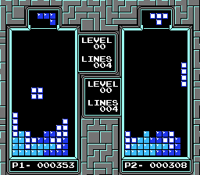
(from https://www.romhacking.net/hacks/5076/)

4. Sound Effects
Sound Effect Name | Brief Description | Event which Triggers Playback
Tetrimino Soft Drop Placement  (Asynchronous) | A “gliding” continuous type sound effect | User continuously holds the down arrow key for the “soft drop” function
Tetrimino Hard Drop Placement  (Asynchronous) | A “boom” type sound effect | User presses the spacebar binded to the “hard drop” function
Tetrimino Movement  (Asynchronous) | A “Click” type sound effect | User presses the respective arrow keys binded for movement
Tetrimino Rotate  (Asynchronous) | A “Click” type sound effect, higher pitch | User presses the respective key binded to the “rotate” function
Tetrimino Hold  (Asynchronous) | A “Click” type sound effect, lower pitch | User presses the respective key binded to the “store” function
Successful Line Clear  (Synchronous) | A mild “explosion” type sound effect | Triggered when the player successfully fills an 1 entire row of tetriminos (no holes, one entire matrix row is “complete”)
Successful “Tetris” Line Clear  (Synchronous) | A loud “explosion” type sound effect | Triggered when the player successfully fills 4 entire rows of tetriminos and must be in filled in a 4 row sequence (no holes, 4 adjacent matrix rows are “complete”)
? Game Over (Synchronous) | An “alarm” type sound effect | ? Potentially optional, wrote this sound effect down as could be helpful in testing purposes + enhances user game experience

[Optional: brief description of background music. Music will be required by assignment 3.]
→ Aaron’s playing the Tetris theme on guitar.

5. Additional Features (Time Permitting)
Have combo multipliers when players multiple clear lines in a row (back to back).
“Next in Queue” display for the next block they will use after placing their current block.
Block statistics (how often have they used a specific block).
Rotate block left button.
A timer that times the player’s gameplay from start to finish.
Highscore system that records the top 5 highest scores.
Clear 40 lines gamemode. This gamemode will time players on how fast they can clear 40 lines and the game ends when they have successfully cleared <= 40 lines.
Any features above marked with a ‘?’ above (i.e ghost piece object, game over sound effect, etc)

